
Synopsis

Property managers spend a great deal of their time in the field inspecting properties, units and common areas as well as communicating with residents and maintenance personnel. In the course of these activities they come across a variety of issues that need to be recorded for later follow-up. This project is focused on developing a client-server application allowing property managers to quickly and easily record Multi-media Memos using their PDA or smart phone devices. The key to the success of this feature is ease of use.

Specifications

Usage Scenario

- The user launches the Memo Logger Application (MLA)by pressing an easily accessible hard or soft button on the device.
- MLA responds by providing the user with choices as to the type of information to add to the memo such as text, voice, picture(s), video; some notes:
  - The MLA should not normally require the user to interact repeatedly with the device’s user interface in order to record a Memo; in other words the user should be able to execute the last / favorite memo pathway via only a few and ideally a single “select” or “enter” action;
  - If connection to server is not detected, the application will log the recorded memo data when one becomes available;

A Possible User Scenario Visualized

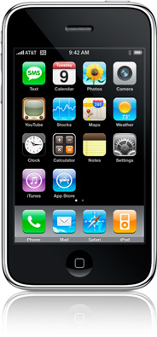
- User presses a button on the handheld device (soft or hard button) to activate the Memo Logger application.
- Memo Logger application launches and displays a user interface whereby it queries the user as to the type of memo to be recorded (default is a voice memo) as well as memo saving preferences; the Start button is in focus by default which means that if the user presses the “select” or “enter” button on the handheld, a voice memo recording will start (without need to use a pointing device or additional keystrokes)
Select memo preferences:
voice
picture
video
Text note (optional):
Start
none
Save:
locally
server
both
Inspect and repair concrete sw parking lot

- Depending on the combination of memo options selected, Memo Logger guides the user through a few screens when the Start button is pressed:
  - Voice only selected: after the Start button is pressed, Memo Logger enters a mode whereby a timer is displayed and recording commences:

Recoding voice memo
Stop Recording
00:25 sec

The user presses the Stop Recording button when he is finished with voice memo recording; Memo Logger allows for up to a 60 seconds of recording;

  - Voice + picture: after the Stop button has been pressed on the Voice Memo recording screen, Memo Logger enters a mode whereby it allows the user to view a live video stream and take a picture:

Press button to take picture…
Take Picture

The user presses the Take Picture button and Memo Logger saves the image to a temporary location;
  - Voice + video: after the Stop button has been pressed on the Voice Memo recording screen, Memo Logger enters a mode whereby it displays a live video stream and allows the user to begin capturing a video segment (maximum 20 s long):

Press button to take video…
Capture Video

The user presses the Capture Video button and Memo Logger starts to record and display the live video stream; the Button changes to Stop Capturing Video; when user presses the “Select” or “Enter” button on the device, the video recording stops and Memo Logger moves to the finalization screen per below:

Memo Nov 18, 2008 4:35pm
Save & Do another Memo
Inspect and repair concrete sw parking lot
Voice Memo: yes (18 seconds)
Picture: yes
Video: yes (19 seconds)
Save & Log
Cancel & Exit

Once the user presses the Save & Log button, Memo Logger saves the memo object (format to be determined) locally and/or to the Server depending on user memo preferences defined in the first screen.
When saved locally, the Memo objects must be saved as a singular file to allow for easy retrieval at a later date. In other words it should be possible to download each saved memo in its entirety using the device’s standard file synchronization mechanism and be able to view the memos on the personal computer using existing applications. One possibility is to save the Memo as a Microsoft Outlook email message with the voice, picture and video content appearing as attachments.

Saving to the Server involve serialization of the Memo object into XML and transmission, reception and logging to database into a SQL Server database.

System Block Diagram
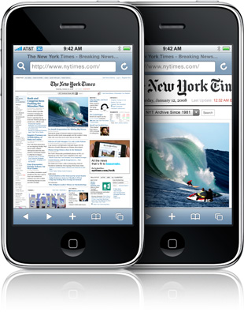

MS IIS Server
(Internet Information Services)

Internet
Handheld Device (iPhone or Blackberry) running MLA
SOAP XML messages
SQL Server
Database
Server Application

Platforms, Tools, Languages

Client Side:

Platforms
- RIM Blackberry
- Nokia

Languages:
- Java

Server Side:

Web Server
- Microsoft IIS Server
Database:
- MS SQL Server
Languages:
- C# or VB.NET

Deliverables

The following is a preliminary list of

- Memo Logger Application (client side) capable of:
Log
in
  - Recording user selectable text, voice, picture and video memos
  - Serializing and transmitting memo objects to the Server Application

- Microsoft IIS Server Application capable of:
  - Receiving serialized memo objects in XML format and de-serializing;
  - Logging the Memo object and associated files to a MS SQL Server database;
  - Sending confirmation/error code back to the Memo Logger Application;
- Documents / Resources / Code:
  - Complete written report describing project stages, test results, and findings;
  - Block diagrams indicating components and subcomponents of each application as well as flowcharts showing flow of data and execution within each application;
  - Specifications including names, versions and web links for tools, drivers, or other resources used in the development of above applications ;
  - Complete code documentation identifying classes, functions, arguments and descriptions;
  - Documented source code files for both Client and Server applications and any other supporting components;

